DOCUMENTATION

ASSIGNMENT 3

STUDENT NAME: Fatan Cristina
GROUP: 30224

CONTENTS

1. Assignment Objective 3
2. Problem Analysis, Modeling, Scenarios, Use Cases 3
3. Design 4
4. Implementation 5
5. Results 7
6. Conclusions 7
7. Bibliography 7

Assignment Objective
Main objective:
Design and implement an application for managing the client orders for a warehouse.
Sub-objectives :
- Analyze the problem and identify requirements
- Design the simulation application
- Implement the simulation application
- Test the simulation application

Problem Analysis, Modeling, Scenarios, Use Cases
Functional Requirements:
- The simulation application should allow an employee to add a new client
- The simulation application should allow an employee to add a new product
- The simulation application should allow an employee to update client and product tables

Non-functional Requirements:
- The application should be intuitive and easy to use by the user
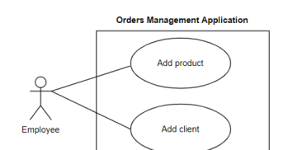
Use Case: add product
Primary Actor: employee
Main Success Scenario:
- The employee selects the option to add a new product
- The application will display a form in which the product details should be inserted
- The employee inserts the name of the product, its price and current stock
- The employee clicks on the “Add” button
- The application stores the product data in the database and displays an acknowledge message
Alternative Sequence:
Invalid values for the product’s data
- The user inserts a negative value for the stock of the product
- The application displays an error message and requests the user to insert a valid stock
- The scenario returns to step 3

Design
The
Conceptual Architecture
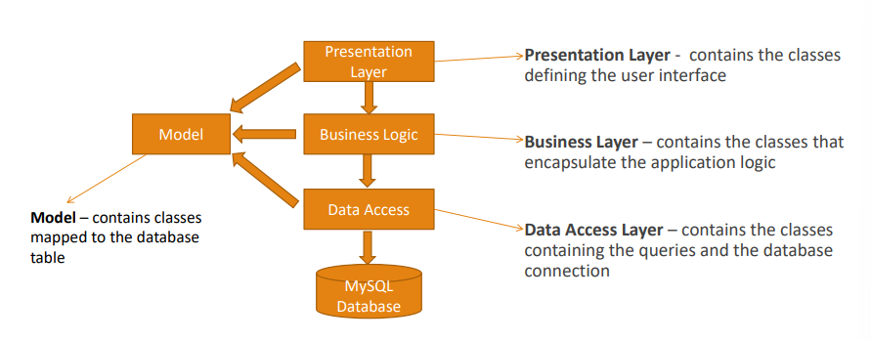
UML diagram:
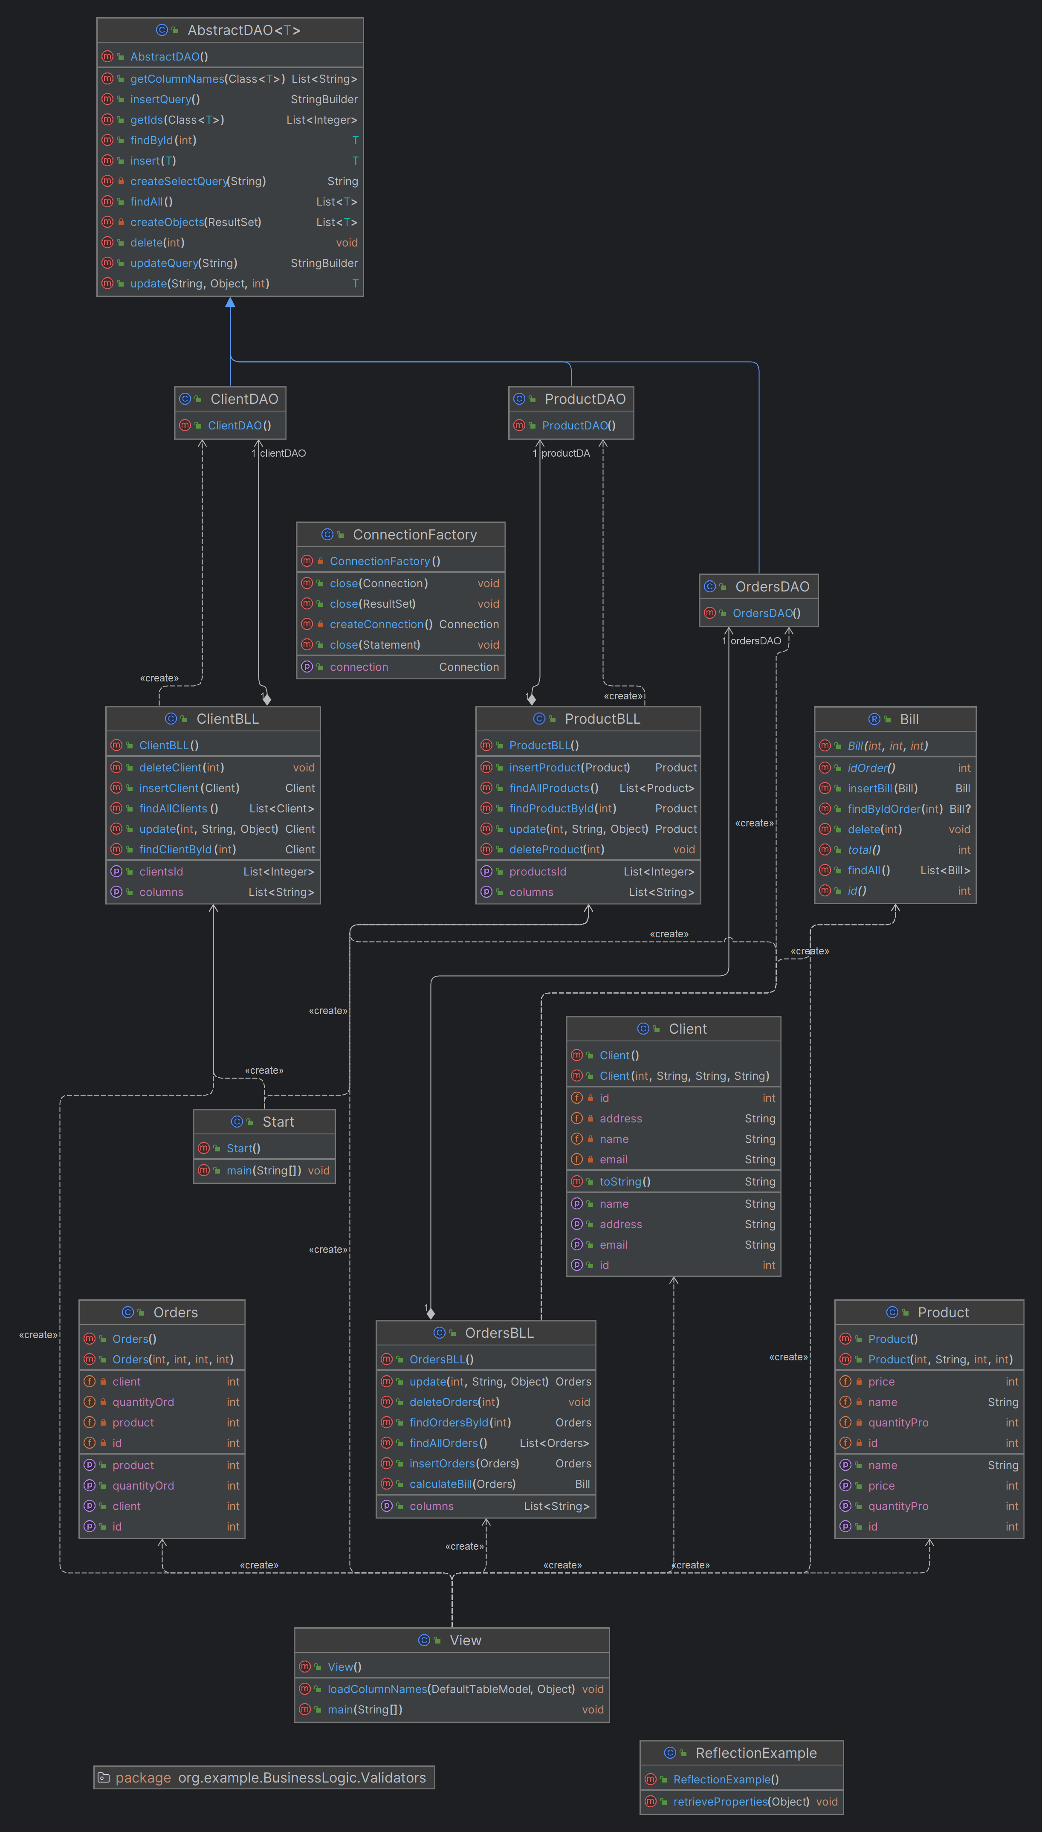

Implementation
1.Product:
- Purpose: Represents a product with an ID, name, quantity, and price.
- Important Methods:
- `getId()`, `setId(int id)`: Getters and setters for the product ID.
- `getName()`, `setName(String name)`: Getters and setters for the product name.
- `getQuantityPro()`, `setQuantityPro(int quantityPro)`: Getters and setters for the product quantity.
- `getPrice()`, `setPrice(int price)`: Getters and setters for the product price.

2. Orders:
- Purpose: Represents an order with an ID, client ID, product ID, and quantity ordered.
- Important Methods:
- `getId()`, `setId(int id)`: Getters and setters for the order ID.
- `getClient()`, `setClient(int client)`: Getters and setters for the client ID associated with the order.
- `getProduct()`, `setProduct(int product)`: Getters and setters for the product ID associated with the order.
- `getQuantityOrd()`, `setQuantityOrd(int quantityOrd)`: Getters and setters for the quantity of the product ordered.

3. Client:
- Purpose: Represents a client with an ID, name, email, and address.
- Important Methods:
- `getId()`, `setId(int id)`: Getters and setters for the client ID.
- `getName()`, `setName(String name)`: Getters and setters for the client name.
- `getEmail()`, `setEmail(String email)`: Getters and setters for the client email.
- `getAddress()`, `setAddress(String address)`: Getters and setters for the client address.

4. Bill:
- Purpose: Represents a bill with an ID, associated order ID, and total amount.
- Important Methods:
- `insertBill(Bill b)`: Inserts a bill record into the database.
- `findAll()`: Retrieves all bill records from the database.
- `findByIdOrder(int idOrder)`: Finds a bill by its associated order ID.
- `delete(int id)`: Deletes a bill record by its ID.
5.ProductDAO:
- Purpose: This class is responsible for interacting with the database to perform CRUD operations specifically for the `Product` entity.
- Important Methods:
- `insert(T t)`: Inserts a new product into the database.
- `update(String column, Object value, int id)`: Updates a specific column of a product in the database.
- `delete(int id)`: Deletes a product from the database by its ID.
- `findAll()`: Retrieves all products from the database.
- `findById(int id)`: Retrieves a product from the database by its ID.

6.OrdersDAO:
- Purpose: Similar to `ProductDAO`, this class is responsible for CRUD operations for the `Orders` entity.
- Important Methods: Same as `ProductDAO`.

7.ClientDAO:
- Purpose: This class handles CRUD operations for the `Client` entity.
- Important Methods: Same as `ProductDAO`.

8.AbstractDAO:
- Purpose: This is an abstract class providing generic methods for CRUD operations that can be inherited by other DAO classes.
- Important Methods:
- `getIds(Class<T> type)`: Retrieves all IDs from the table corresponding to the specified entity type.
- `getColumnNames(Class<T> type)`: Retrieves all column names from the table corresponding to the specified entity type.
- `findAll()`: Retrieves all objects from the table corresponding to the specified entity type.
- `findById(int id)`: Retrieves an object by its ID from the table corresponding to the specified entity type.
- `insert(T t)`: Inserts an object into the table corresponding to the specified entity type.
- `update(String column, Object value, int id)`: Updates a specific column of an object in the table.
- `delete(int id)`: Deletes an object from the table by its ID.

9.ProductBLL:
- Purpose: This class contains the business logic for handling products.
- Important Methods:
- `findProductById(int id)`: Finds a product by its ID.
- `insertProduct(Product product)`: Inserts a new product into the database.
- `update(int id, String column, Object value)`: Updates a product's column with a new value.
- `deleteProduct(int id)`: Deletes a product by its ID.
- `getColumns()`: Retrieves all column names from the product table.
- `getProductsId()`: Retrieves all product IDs.
- `findAllProducts()`: Retrieves all products from the product table.

10.OrdersBLL:
- Purpose: This class contains the business logic for handling orders.
- Important Methods:
- `findOrdersById(int id)`: Finds an order by its ID.
- `insertOrders(Orders order)`: Inserts a new order into the database, validates the order, and checks product quantity.
- `update(int id, String column, Object value)`: Updates an order's column with a new value.
- `deleteOrders(int id)`: Deletes an order by its ID.
- `calculateBill(Orders order)`: Calculates the bill for an order.
- `getColumns()`: Retrieves all column names from the orders table.
- `findAllOrders()`: Retrieves all orders from the orders table.

11.ClientBLL:
- Purpose: This class contains the business logic for handling clients.
- Important Methods:
- `findClientById(int id)`: Finds a client by its ID.
- `insertClient(Client client)`: Inserts a new client into the database.
- `update(int id, String column, Object value)`: Updates a client's column with a new value, validates the email if the column is email.
- `deleteClient(int id)`: Deletes a client by its ID.
- `findAllClients()`: Retrieves all clients from the client table.
- `getClientsId()`: Retrieves all client IDs.
- `getColumns()`: Retrieves all column names from the client table.

12.Validator
- This interface Validator defines a contract for classes that will perform validation on objects of type T. It declares a single method validate that takes an object of type T as a parameter and returns void. Classes that implement this interface will provide their own implementation for the validate method, tailored to the specific validation logic needed for the type T.

13.EmailValidator
- The EmailValidator class provides a reusable component for validating email addresses specifically tailored for instances of the Client class. It uses a regular expression pattern to determine the validity of the email address provided. If the email does not match the expected pattern, it throws an exception. This class helps enforce data integrity and validation rules in applications where accurate email addresses are required.

14.ConnectionFactory
- The `ConnectionFactory` class encapsulates database connection management logic, providing methods to establish connections and close resources safely. It promotes code reusability, robust error handling, and ensures efficient resource management when interacting with databases.
-`getConnection()`:
- Returns a `Connection` object to the database using the specified URL, username, and password.
- Utilizes the `createConnection()` method internally to establish the connection.

- `close(Connection connection)`, `close(Statement statement)`, `close(ResultSet resultSet)`:
- These methods are responsible for closing the database resources (`Connection`, `Statement`, and `ResultSet`) respectively.
- They handle potential `SQLExceptions` that may occur during the closing process and log warnings using the `Logger` class.
- Ensures that database resources are properly released, preventing resource leaks and improving application performance.

15. View
-This class, `View`, is the graphical user interface (GUI) of an application for managing client data, product data, orders, and bills. Here's an overview:

- Purpose:
- Creates a GUI for interacting with the application's functionalities.
- Allows users to view, insert, update, find, and delete data related to clients, products, orders, and bills.

- Features:
- The GUI is divided into multiple tabs, each representing different aspects of the application's functionality (client data, product data, orders, and bills).
- For each tab:
- Displays a table containing data retrieved from the database.
- Provides input fields and buttons for performing CRUD (Create, Read, Update, Delete) operations on the corresponding data.
- Implements action listeners for buttons to execute operations such as inserting, updating, finding, and deleting records.
- Utilizes Swing components like `JFrame`, `JPanel`, `JTabbedPane`, `JTable`, `JScrollPane`, `JLabel`, `JTextField`, `JButton`, `JComboBox`, and `JTextPane` for building the GUI.
- Implements methods like `loadColumnNames()` to dynamically load column names for the tables based on the class properties.

- Integration with Business Logic Layer:
- Utilizes Business Logic Layer (BLL) classes like `ClientBLL`, `ProductBLL`, `OrdersBLL`, and `Bill` to interact with the database and perform business logic operations.
- Calls methods from BLL classes to fetch data from the database, insert/update/delete records, and perform other business logic operations.

- Main Method:
- Contains the `main()` method to instantiate and display the GUI by creating an instance of the `View` class.
- Sets the visibility of the GUI to `true` to make it visible to the user.

Conclusions
This project provides a user-friendly interface for managing client, product, order, and billing data efficiently.
Utilizing Swing components, it offers a tabbed layout for easy navigation and organization of functionalities.
Integration with the Business Logic Layer ensures seamless interaction with the database, maintaining data integrity and adherence to business rules.
With features for CRUD operations and dynamic loading of data into tables, users can easily perform tasks like insertion, updating, finding, and deletion of records.
Overall, this project offers a scalable and extensible solution for businesses to streamline their data management processes, enhancing productivity and decision-making capabilities.

Bibliography
https://www.geeksforgeeks.org/
https://stackoverflow.com/

